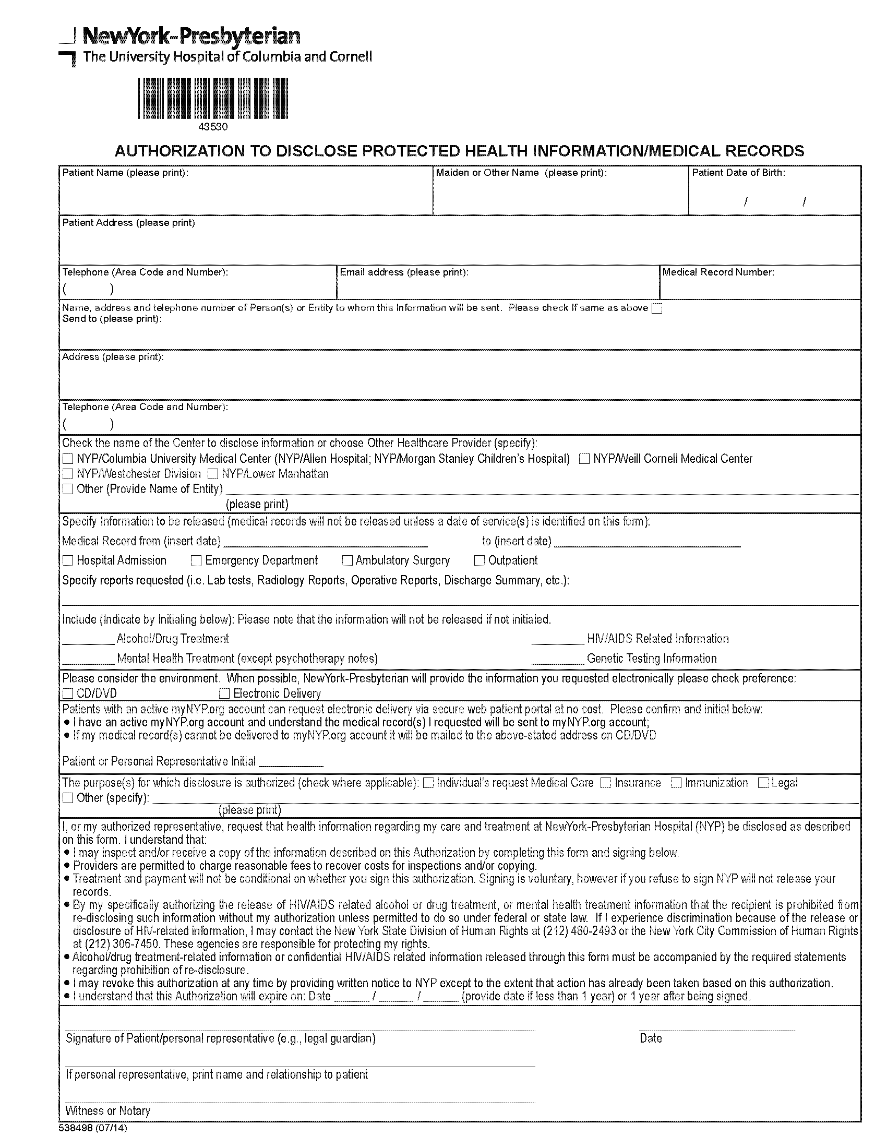
Kyle Washington a/k/a Tilet Washington

06/24/1969
,
Axiom Requisition Copy Service
2869 Jolly Road Okemos, MI 48864
PH: (877) 886-5090 Fax: (517) 886-4116
X
X
